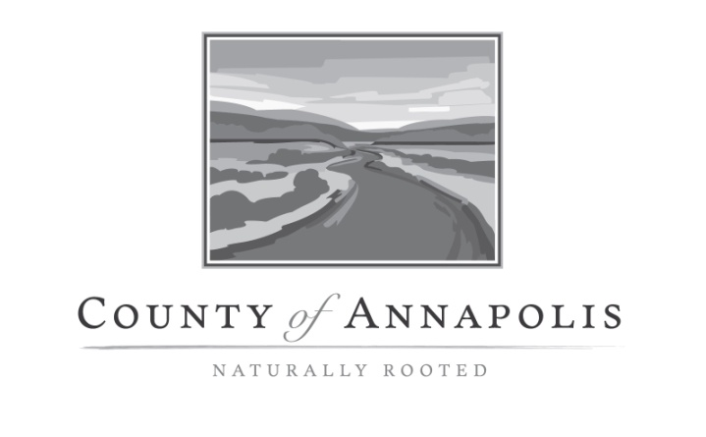

|  |  |
| --- | --- |
| Job title | **Administrative Assistant (Community Development)** |
| Reports to | ***Office Coordinator / Development Officer*** |
| Next Level Manger | ***Director of Community Development*** |

**Job Summary**

The Administrative Assistant is a member of the administrative support team for Community Development. Generally, the Administrative Assistant is a member of the administrative support team to the Director of Community Development/Municipal Planner and reports to the Office Coordinator. The position performs a wide range of administrative functions.

**Duties and Responsibilities**

* Greets the public, responding to questions and, as necessary, refers members of the public to specific Municipal employees, provincial agencies, or proper authority.
* Reviews all incoming mail, faxes and social media and distributes to appropriate staff; reviews and distributes all email to appropriate staff; processes incoming and outgoing mail.
* Collects contact information and maintains an efficient database in MS Outlook for staff use including external community contacts such a contractors, suppliers, government agencies
* Receive and prepare payment receipts for property taxes, permit application fees, sewer and water service invoices, dog registrations and other revenue received for the Municipality.
* Performs SAP related activities associated with invoicing, accepting payments and daily deposits (complete deposit slips, compile daily cash reports and notify Manager of Revenue to sign off).
* Assists residents with tax exemption forms and provincial senior’s rebate forms.
* Assists staff with uploading & updating information for Community Development to our website.
* Research/prepares data for specials projects as assigned by staff.
* Assists Office Coordinator with vehicle maintenance records for fleet vehicles in our Lawrencetown location (inputting of vehicles costs for budgetary reports, making appointments for vehicles maintenance as required, tracking mileage, etc).
* Provides support to the municipality’s record management system.
* Assists Office Coordinator with receiving all development and building permit applications, correspondence as required by building official, file maintenance, monthly reports. Maintain our excel database, PDX Portal (this also includes tracking dates of permit issuance and inspection dates to ensure all permit approvals are up to date and accurate as per our Building Bylaw).
* Assist Office Coordinator with correspondence as it relates to fire inspection.
* Provides administrative support to all staff for Community Development or any other department as required. On occasion, may include providing coverage at other administrative offices in Bridgetown and Annapolis Royal.
* Liaises with other departments, councillors and the public.
* Participates in ongoing planning, testing and implementing continuous improvement in administrative systems and processes.
* Prepares agendas, drafts minutes and assists in the coordination and follow up action on Council and Committee motions, decisions and directions as assigned
* Other related duties as may be assigned by the Office Coordinator or the Director of Community Development

**Qualifications**

*Required Skills:*

* Post-secondary office administration education, minimum three years experience performing duties at a *mid-level office administrator*
* Mid to high level proficiency in Microsoft Office Suites
* WHMIS

*Desirable Skills:*

* Work experience and training in municipal government environment.
* Knowledge of building construction terminology
* Training in SAP
* First Aid

**Competencies**

**Values Diversity -**Valuing Diversity is the ability to understand and respect the practices, customs and values of other individuals and cultures. Diversity is beneficial to the organization and community. It applies the ability to work effectively with a wide cross-section of the community representing diverse backgrounds, cultures and socio-economic circumstances, and divergent goals.

**Communication -** Communication is effective, timely, and relevant exchange of information that is respectful of the diversity of people, and the geography and working environments of our employees. It includes receiving information, listening, understanding and responding openly and effectively in interactions with others. It also implies this information is processed into actions.

**Citizen Services** - Implies a desire to help or serve others in a courteous and respectful manner and with the goal of meeting their needs. It means focusing one’s efforts on discovering, meeting and balancing the needs of citizens, residents, elected officials, internal colleagues, or anyone that the person is trying to help. This involves recognizing that municipal employees are providing services and information to those who have rights and obligations (taxpayers and residents).

**Achievement Motivation -** Focuses efforts on working well and / or competing against a standard of excellence while achieving high quality results.

**Work Safety -** Employees have a responsibility to take all reasonable and necessary precautions to ensure their health and safety and that of anyone else who may be affected by their work or activities. This includes adhering to safe practices and standard operating procedures established to reduce risks. Failure to do so is grounds for disciplinary action in accordance with the County’s policies regarding managing unsatisfactory performance.

**Duty of Loyalty -** As a representative of the County of Annapolis, every employee has a legal obligation to avoid acting in a manner that’s contrary to the County’s interests. This includes refraining from public criticism of the County’s practices or personnel, as well an obligation to maintain confidentiality. Failure to do so is grounds for disciplinary action in accordance with the County’s policies regarding managing unsatisfactory performance.

**Working conditions**

This position must:

* Have a valid Nova Scotia Class 5 driver’s license and a reliable method of transportation
* Be physically and emotionally able to cope with stresses and responsibilities associated with the position.
* Attend meetings, both at and away from the office and some will be outside normal business hours

**Physical requirements**

This position works in an office environment

**Direct reports**

None

**CERTIFICATION**

|  |  |
| --- | --- |
| Employee Signature    Printed Name Date  I certify that I have read and understand the responsibilities assigned to this position. | Supervisor’s Title    Supervisor’s Signature Date  I certify that this job description is an accurate description of the responsibilities assigned to the position. |
| Chief Administrative Officer’s Signature Date  I approve the delegation of responsibilities outlined herein within the context of the attached organizational structure. | |

The above statements are intended to describe the general nature and level of work being performed by the incumbent(s) of this job. They are not intended to be an exhaustive list of all responsibilities and activities required of the position.