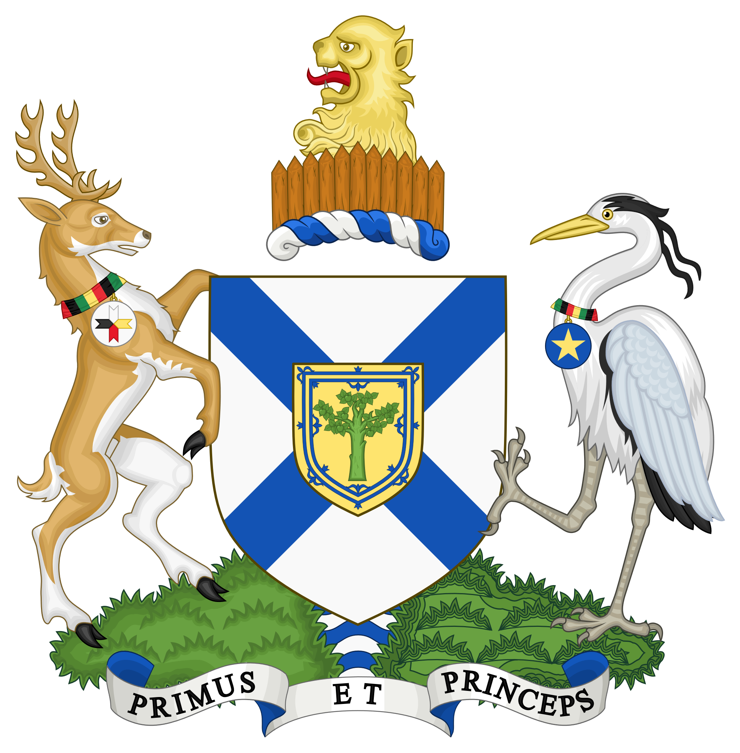 | Municipality of the County  of Annapolis  JOB DESCRIPTION | Position Title:  BYLAW ENFORCEMENT OFFICER
 | Union / Non-Union: NON-UNION | Classification Type: FULL-TIME
 | Salary Classification: RANGE 4 | Approval Date: JULY 24, 2025
General Job Responsibility
Bylaw Enforcement Officer shall be responsible for dealing with complaints related to municipal bylaw infractions, dangerous or unsightly premises. This includes carrying out the duties of a Special Constable, keeping abreast of legal issues and processes related to summary offence tickets and long form summons, assisting with provisions of Fences and Detention of Stray Livestock Act, assisting with enforcement of issues related to cabin bins, provides regular council, public, and staff education of department activities. The Bylaw Enforcement Officer also provides leadership by acting as animal control officer for the Municipality and other municipalities under contract, helps with maintaining dog stations, and assists other department with the servicing and posting of legal notices.
This job description is a general outline of duties and responsibilities and is not meant to limit the employee’s initiative to expand or increase their work output subject to approval by their supervisor.
Accountability
This position reports directly to the Manager of Protective Services.
Specific Job Responsibilities
- Under the direction of Manager of Protective Services, conducts investigations into complaints regarding individual properties within Annapolis County that are believed to be dangerous or unsightly. Documents such calls, emails or in-person visits, confirming ownership through Nova Scotia Property On-line, visiting properties under concern, speaking with property owner(s), taking photographs, preparing a preliminary and subsequent investigation reports for discussion with Manager of Protective Services.

- Investigates complaints or concerns regarding animal related bylaw infractions in Annapolis County or other municipalities under contract, documenting such calls, emails or in-person visits, confirming ownership through dog registration system or local contacts, locate, apprehend and impound such animals where required, taking photographs, advertising that an animal or animals have been found or taken into custody. safely and humanely housing animals including feeding, exercising and cleaning of dog pound daily and other animal care housing facilities, issuing dog registration where applicable, gathering evidence, interviewing witnesses, imposing conditions on certain animals, having discussions with provincial officials responsible for animal care, obtaining warrants when required or necessary, determining if a summary offense ticket should be issued, following up with complainant to provide general update while protecting confidentiality of property owner and investigation, generally oversees infraction compliance or legal proceedings until municipal compliance is received, provides affidavits and evidence collection for municipal solicitor or crown prosecutor, attends court and testifies when subpoenaed, followed by closure request of file to Manager of Protective Services.

- Investigates complaints or concerns regarding individuals related to potential contravention of municipal bylaws including noise, solid waste, and other provincial regulations under their jurisdiction, documenting such calls, emails or in-person visits, confirming ownership through Nova Scotia Property On-line, visiting required persons, collecting evidence where appropriate, preparing preliminary and subsequent reports for discussion with Manager of Protective Services

- Investigates complaints or concerns regarding individual properties containing potential illegal dumpsites or waste disposal sites within Annapolis County, as well as staff initiation of illegal dumpsite files that they may come across in the scope of their day-to-day travels that warrant immediate attention, documenting such calls, emails or in-person visits, confirming ownership through Nova Scotia Property On-line, visiting properties under concern, speaking with property owner(s), taking photographs, preparing preliminary and subsequent reports for discussion with Manager of Protective Services.

- Provides leadership support to Manager of Protective Services by acting as animal control officer for the Municipality and other municipalities under contract. Assists in the position of Pound Keeper, working with the provincial SPCA and veterinarians, supports the public and community with education regarding dog and animal care and control, and awareness of municipal and provincial legislation. Provides oversight, maintenance, upkeep, and record keeping for the County dog pound, annually making budget recommendations for repairs and capital improvements to Manager of Protective Services.
- Assists Manager of Protective Services with investigations, documentation, administration, reporting, implementation, and enforcement of work required under the Fences and Detention of Stray Livestock Act of Nova Scotia.
- Investigates complaints of illegal disposal or dumping of waste at cabin bins throughout Annapolis County, seeking to educate residents on the proper use of such bins.

- Carries out all duties and responsibilities of Special Constable when appointed as such under Section 88 of the Nova Scotia Police Act.
- Assists Manager of Protective Services with preparing and providing updates to Municipal Council regarding all dangerous or unsightly files that have been closed during the past three months, or are currently active and their present state.

- Partners with other staff to ensure that dog stations throughout the county are adequately equipped and resourced through regular checks, replacing required supplies, removing waste, and cleaning up around the dog stations to ensure a clean, safe environment for future users.

- Works with Communications Coordinator to ensure municipal websites where bylaw enforcement services are being provided are current and up-to-date to provide timely and accurate access to staff and services, as well as the preparation of high quality, visible and easy to read and understand signage, brochures, pamphlets, and educational materials.
- Assists other municipal departments with projects and activities during the year when requested by Manager of Protective Services, such as serving, posting, or removing legal notices, and filing affidavits.
- Prepares reports and presentations for Manager of Protective Services on various topics and issues during the year as requested.
- Other duties and responsibilities as may be assigned from time to time by the Manager of Protective Services.
Qualifications and Expectations
Candidates for this position must possess as a minimum, a college diploma or certificate in law or law enforcement, corrections, security, social work, or a similar educational program, or a combination of these educational requirements and lived experiences that meet requirements.
Additionally, the candidate must have a minimum of five (5) years experience working in a policing, bylaw enforcement, corrections or security type organization, dog and animal control, with preference given to those whose experience is directly or indirectly working with a municipal government organization, or a combination of formal experience and lived experiences.
Due to the nature of this position, the employee must have strong reading, writing skills, have a positive past working relationship with various segments of the public, be fluent with Microsoft Office, and comfortable working in an environment that has short timelines and high political and social media attention. This position will occasionally require work outside of normal office hours including evenings, weekends, and holidays.

